Jenniffer Estrada | Youngstown State University | October 26, 2015

Socket to the Pi

Raspberry Pi Socket programming

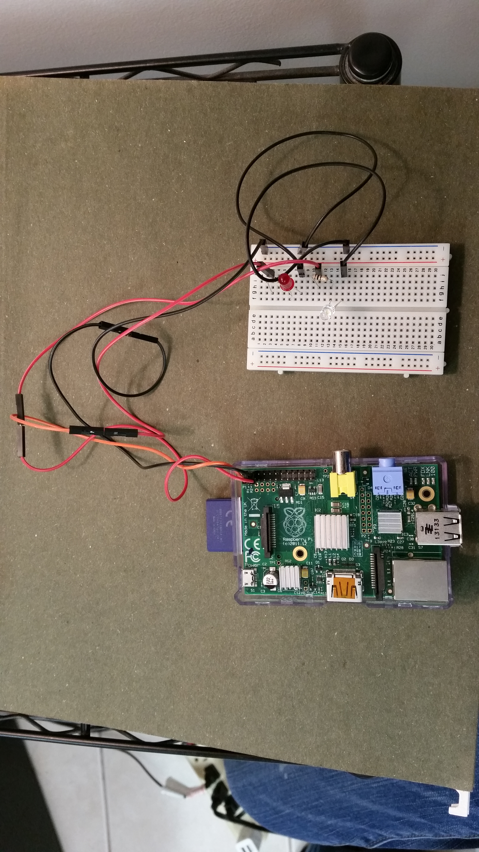

# Materials Needed

Materials needed for this project are:

* Raspberry Pi (version B was used, but newer versions of the Raspberry Pi are supported)
* SD card (blank or with Raspbian OS installed)
* Wi-Fi dongle for the Raspberry Pi (or network switch and Ethernet cables)
* Color LEDs (1 white and 2 red LED were used)
* Resistors
* Wire
* Breadboard
* A computer with internet connection (Wi-Fi)
* Optional monitor, keyboard and mouse

# Set Up

This tutorial assumes that you are new to the Raspberry Pi, and the setup involved in retrieving all pertinent packages and installation of all software.

## Installing Raspbian OS

The operating system used for the raspberry pi resides in a SD card. Depending on the version of the raspberry Pi you decide to you will determine the type of SD card you will require (standard SD card or micro SD card). In this project I used the Raspberry Pi B, which uses the standard SD card, which had 4GB of memory. To install the operating system on the SD card, you first need to retrieve a version of the Raspbian OS from the internet, which can be found here:

<https://www.raspberrypi.org/downloads/>

You have the option of downloading NOOBS or the Raspbian image itself. We will use the Raspbian Wheezy image, instead of using NOOBS.

<https://www.raspberrypi.org/downloads/raspbian/>

Click the Download ZIP. Unzip the compressed folder, and you should find a file with the .img extension, such as:

2015-05-05-raspbian-wheezy.img



Using a blank SD card, and an image burning software, such as Windows Disc Image Burner, you can install the operating system onto the SD card. Make sure to select the correct drive and the .img file. For a basic tutorial on how to burn an image:

<http://www.groovypost.com/howto/windows-7-burn-an-iso-image-to-disc/>

Inset the SD card into the Raspberry Pi, and connect the power cable, monitor, keyboard and mouse to the raspberry Pi. Next, configure the system on the first boot up using the GUI, for the correct settings such as the time zone and keyboard layout.

## Setting up the network

After the configuration of the system, you need to ensure that your system is complete and updated, which requires access to the internet. If you have a Wi-Fi dongle, connect it to the Raspberry Pi. Otherwise, connect the network switch Ethernet cable to the Raspberry Pi to be on the same network as the client. Open up the terminal, LXTerminal, from the Raspberry Pi and type in:

$ ifconfig

ethO will contain the IP address you need to replace in the server script. On the client computer, you need to run ipconfig (Windows) or ifconfig (Linux) on the terminal and get the IP address you need to use for the client script.

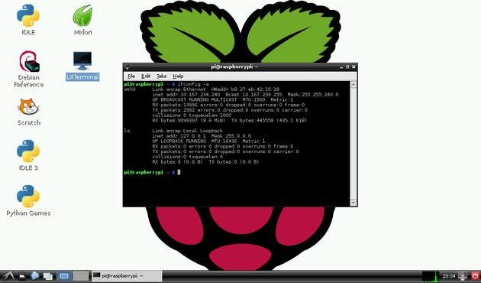

Within the terminal, run the commands

$ sudo apt-get update

$ sudo apt-get upgrade

To ensure that the system is updated to the latest version of the operating system and all packages installed are updated as well.

# Socket Programming

The raspberry Pi Raspbian Wheezy operating system has several built-in tools, including Python. Since python is a relatively easy language for beginners to learn and it is readily available in the raspberry pi, it was chosen as the language of choice for this socket programming example.

## Python Basics

Really briefly, the basics of programming in python will be discussed.

There is a difference between the two current versions of python available, python 2 and python 3. Although subtle differences exist between the two versions, it is best practice to compensate for the python 3 version or make a note that the program works with a certain version. This tutorial works with Python 3.

Python is a general purpose high level programming language, which emphasizes readability and has a large support from the open source community.

## Socket Programming Principles

In the client and server scripts, two modules are imported: socket and RPi.GPIO. The RPi.GPIO is a module to control the Raspberry Pi GPIO and the socket module is a library to create and manipulate sockets. Sockets are a medium used for communicating between two devices, and in this example I used a made up protocol to transmit the messages between the client and the server.

For the program to work, the server script must be run first and then the client. The reason for this is that the server must have the socket open and be listening for the client to connect. The two pieces of information that need to be changed based on your configuration is the IP address and the port number.

The general structure of a socket program between a client and a server is similar to that of a customer and a customer service representative. The customer must initialize a conversation with the customer service representative by saying “hello” and the customer service representative will say “hello back”, assuming that they are paying attention and listening. The idea of the exchange will be to be serviced in some manner, in the case of the Raspberry Pi program, it is to manipulate the LEDs connected to the GPIO of the Raspberry Pi. The client asks the user for the color LED they want to manipulate and the state they want to change the LED to; whether on or off.

color = raw_input("Choose the LED color (white or red or clean): ")

state = raw_input("On or Off state (1 or 0): ")

There is some logic in the script to account for the color and what pin that is on the Raspberry Pi GPIO:

if color == 'white':

num = 3

else:

if color == 'red':

num = 2

else:

print(('Cleaning up...'))

num = 'clean'

state = 0

The string for the LED number and the state that it must be in are encoded to be sent through the socket:

s.send(str(num).encode())

s.send(str(state).encode())

The client expects a response from the server after sending the request, prints out the response to the terminal and closes the socket once the request has been completed:

# Receive no more than 1024 bytes

tm = s.recv(1024).decode()

print(tm)

s.close()

The server script is very similar to the client script, in that it also imports the socket module, but it also imports the RPi.GPIO module:

import socket

import RPi.GPIO as GPIO # Import library

The RPi.GPIO module can be set up in two different ways; BCM or BOARD. For my setup, I used BCM, which has the pinouts based on the BCM chip:

GPIO.setmode(GPIO.BCM) # Setup the RPi board

Although you can also initialize it with BOARD, although this changes the pin layout of the GPIO slightly:

GPIO.setmode(GPIO.BOARD)

After the board GPIO is initialized, the socket must be created on the server side:

# Create a socket object

serversocket = socket.socket(

socket.AF_INET, socket.SOCK_STREAM)

The host is the IP address of your server (raspberry Pi) which was attained from running ifconfig on the terminal. The port between the client and server scripts must match. Next the socket must bind to a port and listen for requests. I enabled up to 5, which means that using threads and parallel programming, the server can handle several requests simultaneously. I leave it to the user to handle multiple requests if they choose, but for the purpose of this project, I only handled one request at a time.

# Bind to the port

serversocket.bind((host, port))

# Queue up to 5 requests

serversocket.listen(5)

print(("Server Running. IP: " + str(host)))

In a loop, we handle the incoming requests to the server:

while True:

# Establish a connection

clientsocket, addr = serversocket.accept()

print(("Got a connection from " + str(addr)))

num = clientsocket.recv(1024).decode()

state = clientsocket.recv(1024).decode()

if num == 'clean':

GPIO.cleanup()

r = "Board reset!"

clientsocket.send(r.encode())

else:

GPIO.setup(int(num), GPIO.OUT) # Select pin

GPIO.output(int(num), int(state)) # Change the state of the selected pin

print(("Recieved state change of " + str(state) + " for pin " + str(num)))

r = "Server executed state change!"

clientsocket.send(r.encode())

clientsocket.close()

The server accepts a valid connection on the port and echoes the IP address of the client. The server decodes the two packets it receives containing the number (num) and the state (state) of the LED the user wants to manipulate from the client. If the choice is to clean the state of the GPIO, then the code to execute the cleanup is run, otherwise, the LED and the state are processed. If the state is a different one than the current one, then the change will occur, otherwise there will be no change noticed. The server prints out the received LED number and state requested, and the GPIO acts accordingly to turn on or off the correct LED. The server responds back to the client that the server successfully executed the request. Once this is complete, the client socket is closed and the server continues to listen for a new connection from a client, until the server program is terminated.

# Using GPIO and Socket Programming

## Installing GPIO library

To install the GPIO library, there are a few options, depending with how comfortable you are with Linux and the Raspberry Pi environment.

**Manually**

I have manually installed the GPIO library manually, and to do such used the following process. First, on the Raspberry Pi download the module from:

<https://pypi.python.org/pypi/RPi.GPIO>

The RPi.GPIO comes in a Tape Archive (tarball) and gzipped (compressed), which is similar to a .zip file in Windows. This file needs to be unzipped to be used, using the package manager or the command line by navigating to the location of the file and running the command:

$ tar xvfz filename.tar.gz

so, in our case,

$ tar xvfz RPi.GPIO-0.5.11.tar.gz

This module can be imported within Python and referred to in the server script by using GPIO:

**import** **RPi.GPIO** **as** **GPIO**

I kept the RPi.GPIO library in the same folder as the server script. Remember to run the script as the super user, to ensure that you have permissions necessary to execute the script. It might be a good idea to include an exception to throw an error to handle this as well:

**try**:

**import** **RPi.GPIO** **as** **GPIO**

**except** **RuntimeError**:

**print**("Error importing RPi.GPIO! This is probably because you need superuser privileges. You can achieve this by using 'sudo' to run your script")

It is worth mentioning that the library can be downloaded and installed through the repository. That process is outlined below.

**Repository**

Instead of installing the module from the repository, since it comes with the Raspbian Wheezy release. Open a command line and type in:

$ sudo apt-get update  
$ sudo apt-get install python-rpi.gpio python3-rpi.gpio

### There are a lot of good examples and documentation on the module in the website:

<http://sourceforge.net/p/raspberry-gpio-python/wiki/Examples/>

## Basic electronics design principles

Working with LEDs is easy, although there are a few things to keep in mind. A LED can be thought of as a faucet, in which the water is flowing one direction and must be enabled by hitting a certain threshold from the faucet handle. A LED can also be thought of as a switch in the ideal case, in which the light on the LED turns on once the switch is triggered, by having the correct voltage applied. The LED has two legs, one longer than the other. The long leg is the anode lead, which will always be connected to the battery positive end (where to source of the power is). The cathode is the shorter lead, which is connected to ground (the negative end of the battery or power source). If the direction of the LED leads are swapped, the LED will not turn on. Remember to use a current limiting resistor between the voltage source and the LED to ensure there is no damage caused to the LED from the power source and burn out the LED. You can use a web calculator to calculate the value of the resistor needed for the LEDs you have:

<http://ledcalculator.net/>

 

## Circuit Building

Below is a diagram of the Raspberry Pi GPIO (B, B+, and 2 are included for reference) layout and the circuit diagram of the LED setup for the socket program using two LEDs. The information for the GPIO is available from:

<http://www.raspberrypi-spy.co.uk/2012/06/simple-guide-to-the-rpi-gpio-header-and-pins/>

Revision 1.0:

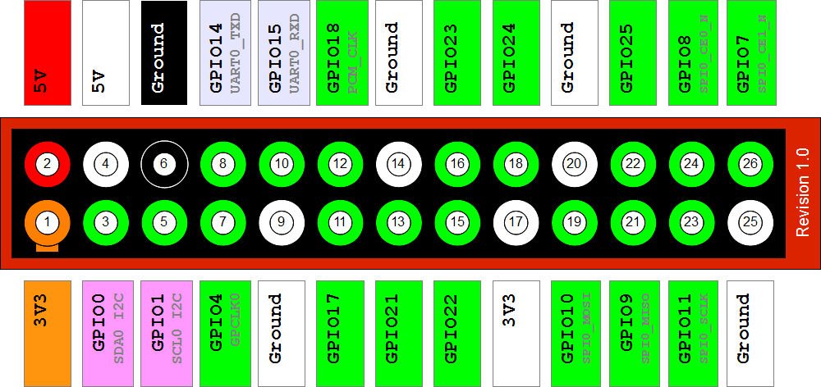

Revision 2.0:

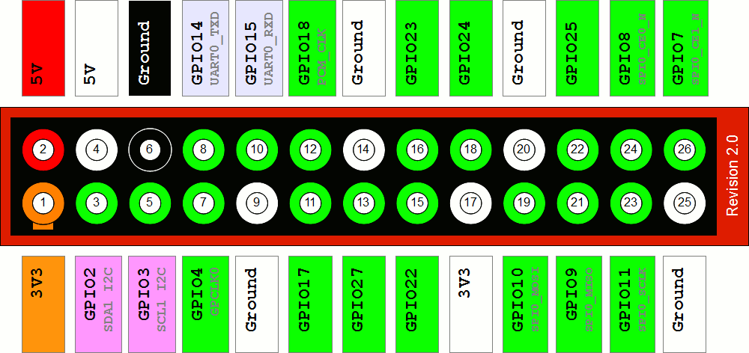

Model B+ and Pi 2 B:

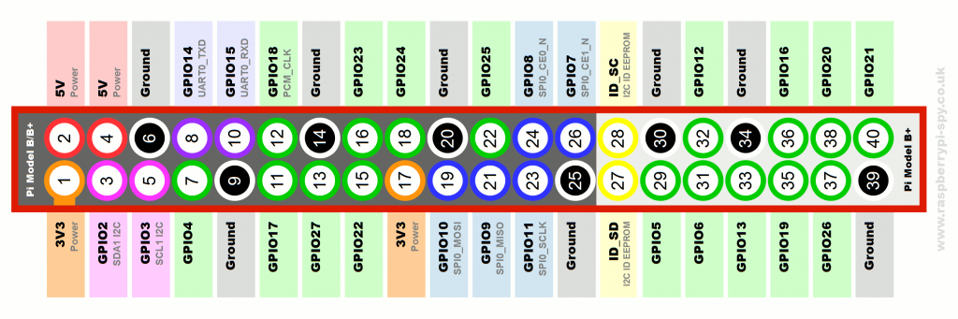

# Another useful diagram for helping with understanding the GPIO layout:

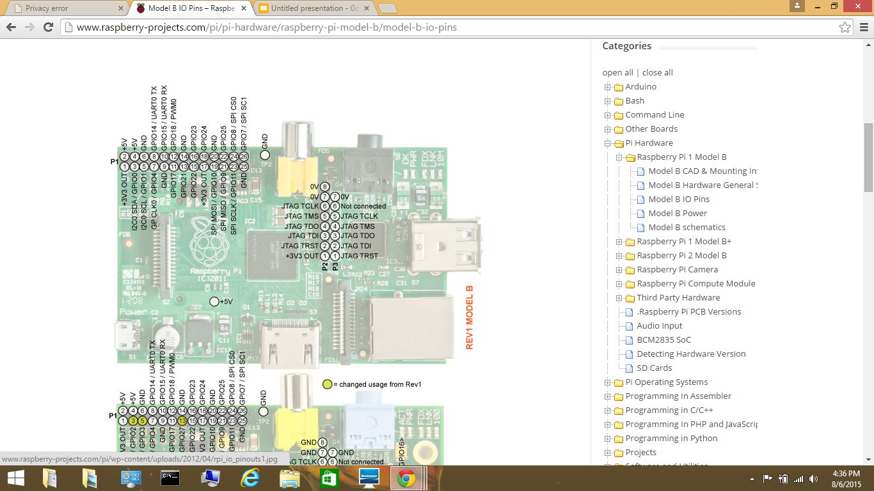

# The final circuit diagram is as follows, with R1 and R2 being the resistance values calculated from the LED resistance calculator (R1=330 and R2=100 ohms, in my case):



# Completed Project

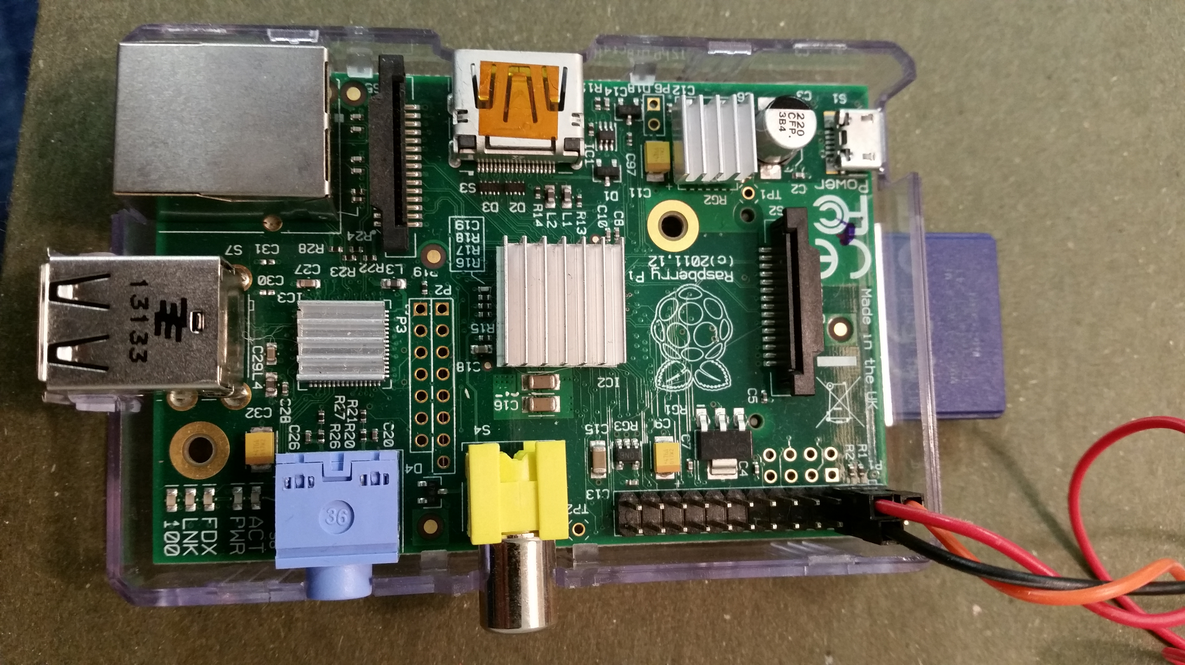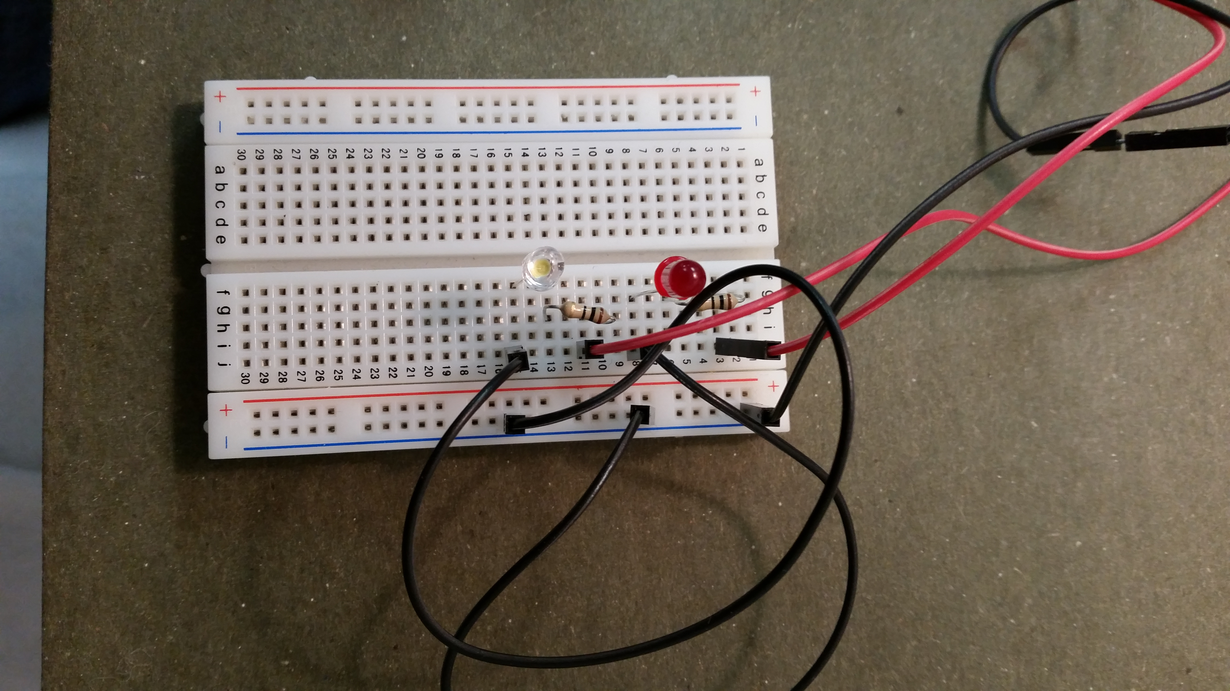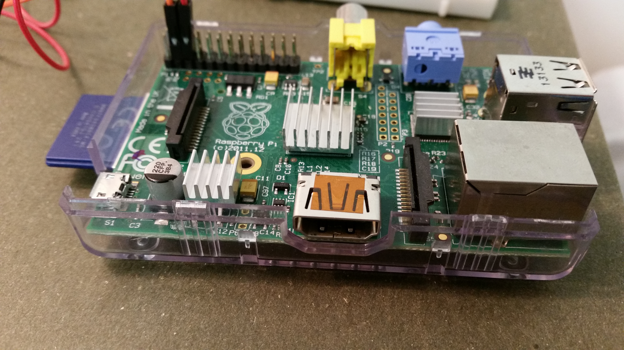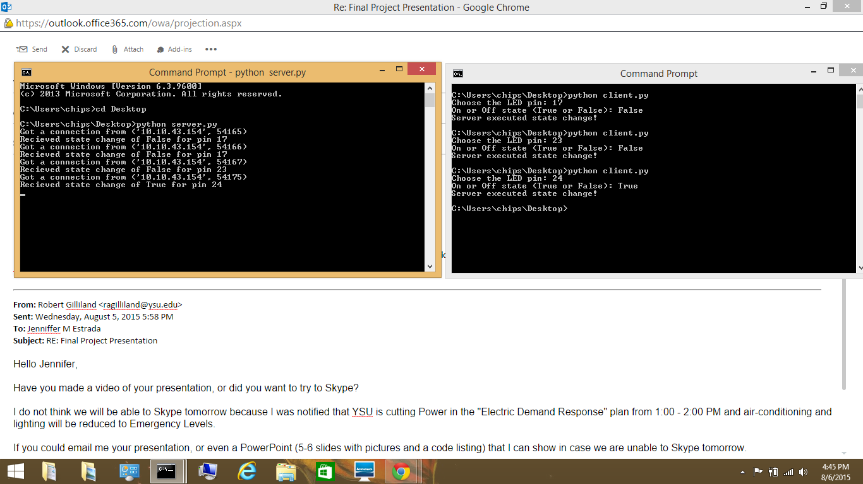

# Code

The finished code for my implementation is below:

### Client Code:

# client.py

import socket

# Create a socket object

s = socket.socket(socket.AF_INET, socket.SOCK_STREAM)

# Get local machine name

host = '192.168.0.26' # Use your correct IP or use socket.gethostname()

port = 9999

# Connection to hostname on the port.

s.connect((host, port))

color = raw_input("Choose the LED color (white or red or clean): ")

state = raw_input("On or Off state (1 or 0): ")

if color == 'white':

num = 3

else:

if color == 'red':

num = 2

else:

print(('Cleaning up...'))

num = 'clean'

state = 0

s.send(str(num).encode())

s.send(str(state).encode())

# Receive no more than 1024 bytes

tm = s.recv(1024).decode()

print(tm)

s.close()

### Server:

# server.py

# NOTE: Run on the raspberry pi after getting RPi.GPIO library

import socket

import RPi.GPIO as GPIO # Import library

GPIO.setmode(GPIO.BCM) # Setup the RPi board

# Create a socket object

serversocket = socket.socket(

socket.AF_INET, socket.SOCK_STREAM)

# Get local machine name

host = '192.168.0.26' # replace with your correct IP or use socket.gethostname()

port = 9999

# Bind to the port

serversocket.bind((host, port))

# Queue up to 5 requests

serversocket.listen(5)

print(("Server Running. IP: " + str(host)))

while True:

# Establish a connection

clientsocket, addr = serversocket.accept()

print(("Got a connection from " + str(addr)))

num = clientsocket.recv(1024).decode()

state = clientsocket.recv(1024).decode()

if num == 'clean':

GPIO.cleanup()

r = "Board reset!"

clientsocket.send(r.encode())

else:

GPIO.setup(int(num), GPIO.OUT) # Select pin

GPIO.output(int(num), int(state)) # Change the state of the selected pin

print(("Recieved state change of " + str(state) + " for pin " + str(num)))

r = "Server executed state change!"

clientsocket.send(r.encode())

clientsocket.close()